**DISASTER RECOVERY WITH IBM CLOUD VIRTUAL SERVERS**

**PHASE-3**

**Disaster Recovery Functions for Tsunami :**

Brief overview of the importance of disaster recovery planning for businesses utilizing cloud services. Explanation of the relevance and significance of IBM Cloud Virtual Servers for disaster recovery purposes.

1. **Requirements:**

* IBM Cloud Account
* Dataset
* Disaster Recovery Plan
* Compliance and Security Measures
* Testing and Validation Procedures
* Deployment

1. **Analysing the Dataset:** By conducting a comprehensive analysis of the dataset, we can

* **Identify Critical Data:** Determine the critical datasets that are crucial for the continuity of business operations and require immediate backup and recovery in the event of a disaster.
* **Evaluate Data Recovery Plan**: Assess the specific points in the dataset where backups should be taken to ensure minimal data loss and maintain data integrity during the recovery process.
* **Understand Data Assess Pattern**: Gain insights into the patterns of data access and usage within our organization to optimize the storage and retrieval processes during disaster recovery.

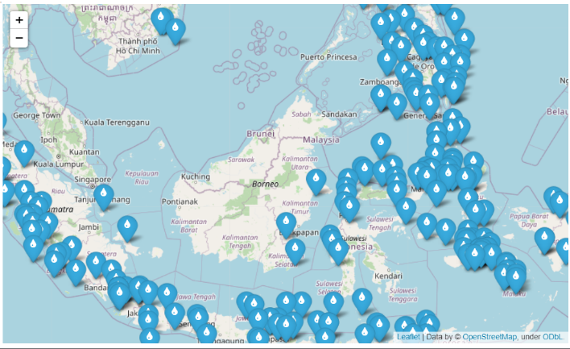

1. **Model Used:**

For predicting the disaster area, specifically in the context of tsunami impact, it is essential to choose a model that can effectively handle spatial data and capture the complex relationships between various environmental factors and the affected area.

* **Convolutional Neural Network**: CNNs are highly effective for extracting meaningful features and patterns for Satellite imagery. They excel at capturing spatial dependencies, making them suitable for predicting the impact of natural disasters in specific geographic regions.

1. **Validation and Testing:**

Hyperparameter tuning is conducted to optimize the model's performance, utilizing metrics such as accuracy, precision, recall, F1-score, and area under the ROC curve. The model is then evaluated on the independent testing dataset to assess its generalization capability. Performance analysis is undertaken to identify any misclassifications and discrepancies between predicted and actual disaster-affected areas, followed by iterative refinement if necessary.

1. **Deployment:**

As we progress with the implementation of our disaster-affected area prediction model, we have successfully exported and serialized the trained model, ensuring compatibility with our deployment infrastructure.